Algebra 3-4 Name: ____________________

Chapter 4 Re-Test Block: ________

For problems 1 – 3, graph and label the vertex and axis of symmetry.

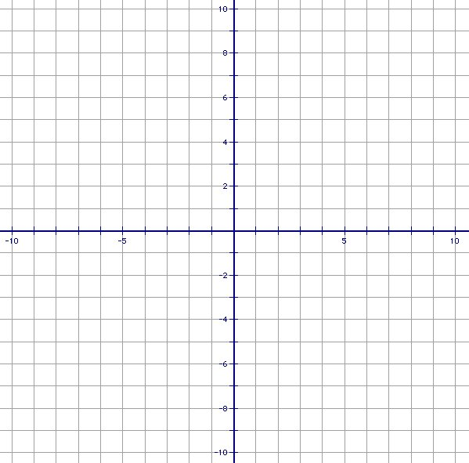
1. 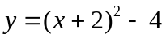

2. 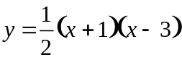

3. 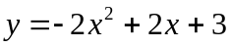

For problems 4 – 5, write the quadratic function in standard form.

4. 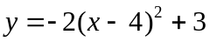

Standard Form: __________________

5. 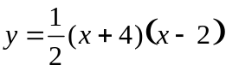

Standard Form: __________________

For problems 6 – 8, write the quadratic function in intercept form and then find the zeros of the function.

6. 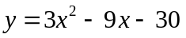

Intercept Form: ________________

Zeros: ________________________

7. 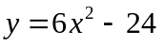

Intercept Form: ________________

Zeros: ________________________

8. 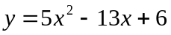

Intercept Form: ________________

Zeros: ________________________
For problems 9 – 10, write the quadratic function in vertex form and identify the vertex.

9. 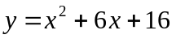

Vertex Form: ____________________

Vertex: _________________________

10. 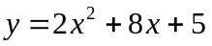

Vertex Form: ____________________

Vertex: _________________________

For problems 11 – 12, graph the quadratic inequality.

11. 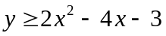

12. 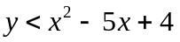

For problems 13 – 14, solve the quadratic inequality.

13. 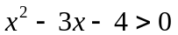

14. 